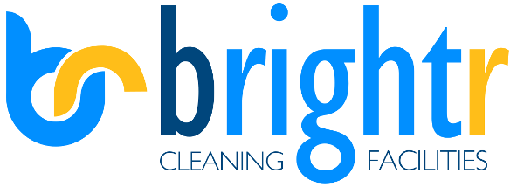

ENVIRONMENTAL POLICY
BRIGHTR LTD IS COMMITTED TO:

- Encourage suppliers and clients alike to conduct operations in an environmentally efficient manner. Caring for the environment and the prevention of pollution.
- Minimising waste, promoting recycling, reducing energy and raw material consumption and reducing harmful emissions.
- Encourage use of new working systems, methods and equipment’s to continually improve our carbon footprint.
- Promote the protection of the environment and minimise the impact of activities upon local, regional and global environments.
- Integrate environmental management policies and practices into every level and every department of the company. Everyone is responsible for the environmental aspects of the company and for minimising the Company’s impact upon the environment.
- Provide safe, healthy working conditions for staff and others.
- Abiding by all relevant environmental legislation and applicable requirements.
- Continually improving our environmental performance by setting objectives, actions and targets.
Chris Savage

Director

